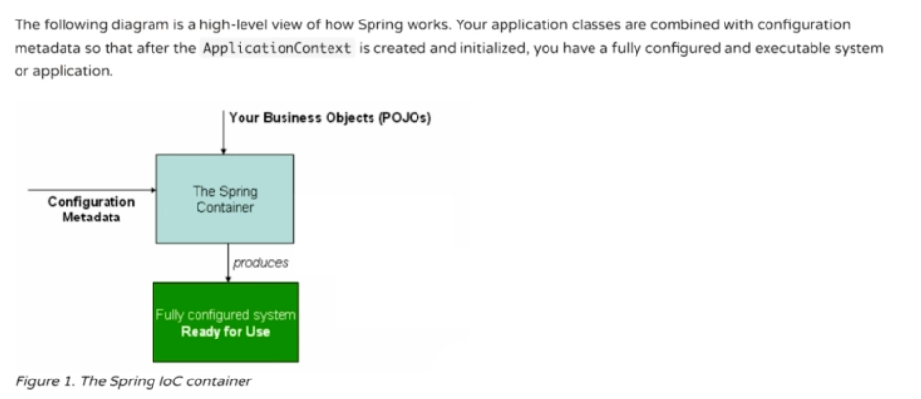

Configuration meta data can be simple xml file or annotations. It is simply data about data.

* **Configuring the Container:**  we can configure a bean in the xml file.



**Bean id:** if we don’t specify it, a random id will be generated.

**Bean class:** Here we have to specify the full class name (package name + class name)

This two will configure and generate a basic bean for us.

* **Instantiating the container:**

The first parameter needs to match the name or id in the xml file. 2nd parameter is the class, in this case we used the interface object which is the java best practice.

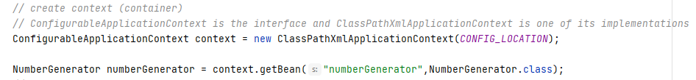



* **Constructor based Dependency Injection:**

In the case of situations where we need constructors, we can config them in the beans.xml file. For example, take this constructor,

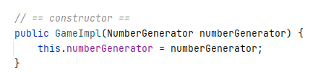

Its configuration would be something like ,

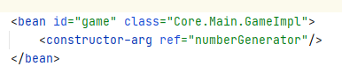

* **Setter based dependency Injection:**

In the case of situations where we need setters, we can also config them in the beans.xml file. For example, take this setter,

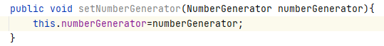

In the config file, property name must match the property/field of the class and ref is the reference to the bean(don’t get confused by the same name in the ss).

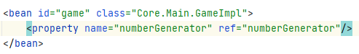

* **Which one to choose?**

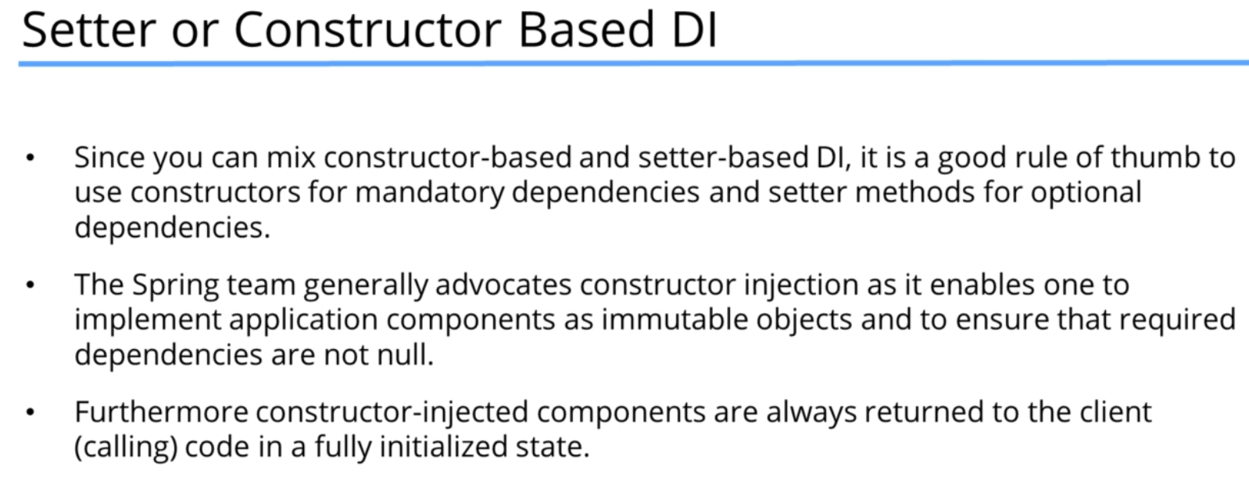

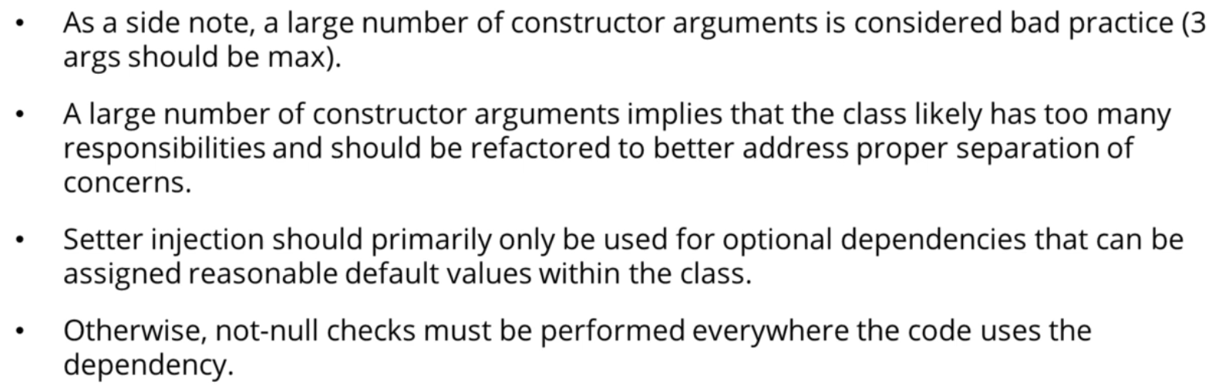

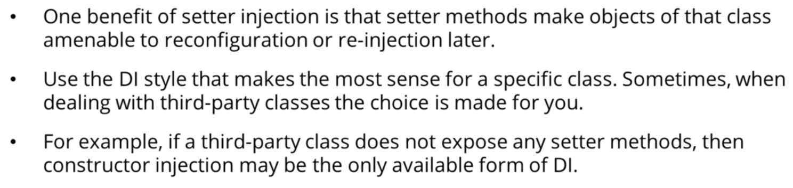

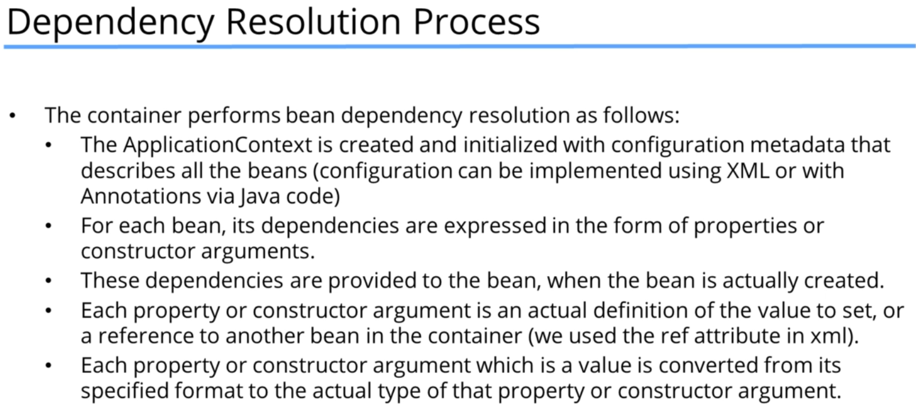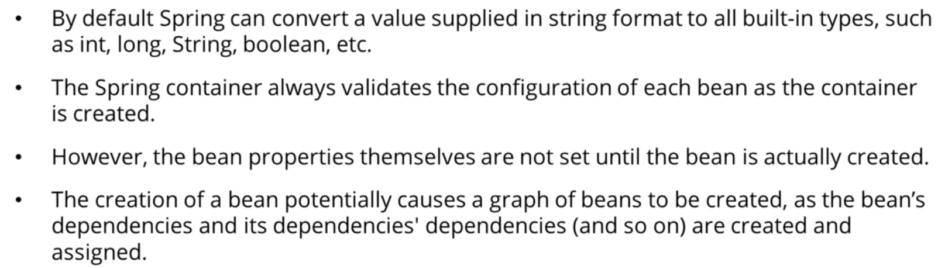

* **Must check:**

